Problem Statement

Product Dissection for top leading Platforms

Welcome to this case study on dissecting and designing products for top leading platforms. In this case study, you will delve into the intriguing world of schema design for a prominent platform of your choice. Your task is to choose a top leading platform, research its features, and meticulously craft a schema design that encapsulates the essence of its functionality. By focusing on key entities, attributes, and relationships, you will gain invaluable insights into how data architecture drives the platform's effectiveness.

Step 1: Choose a Leading Platform
Select a leading platform of your choice, which could span various domains such as social media, e-commerce, finance, or any other industry. This choice will form the foundation of your exploration into its schema design.

Step 2: Research:
Thoroughly research the platform you have selected. Investigate its core features, functionalities, and user interactions. Identify the top features that define its user experience and contribute significantly to its popularity.

Step 3: Product Dissection and Real World Problems solved by the platform
In this step, you will meticulously analyse the platform's standout features and how they provide innovative solutions to real-world challenges. By identifying key functionalities that resonate with users, you'll unravel how the platform effectively addresses problems and enhances user experiences. This dissection will serve as the foundation for understanding how the schema design aligns with the platform's core objectives.

Step 4: Case Study on the real world problems and approach to solving them
In this pivotal step, you will expand on the real-world challenges uncovered in Step 3 through a comprehensive case study. Delve into specific instances where users encountered difficulties and showcase how the platform's unique features provided effective solutions. By dissecting the approach taken by the platform to overcome these challenges, you'll gain a deeper appreciation for the platform's user-centric design philosophy and how it shapes the schema design.

Step 5: Schema Design Based on Top Features
Based on the features you have identified, craft a schema design that reflects the platform's data structure. Focus on the key entities, attributes, and relationships that underpin the chosen features. Your schema should capture the essence of how the platform organises and utilises its data.

Step 6: Rationale Behind the Design
While creating the schema design, consider the rationale behind the platform's choices. Reflect on why certain entities and relationships were chosen and how they align with the platform's goals. This will help you understand the strategic decisions driving the schema's architecture.

Step 7: Create an ER Diagram
Utilise tools like the Miro platform or similar applications to create an illustrative Entity-Relationship (ER) diagram. This diagram should vividly depict the entities, attributes, and relationships present within your schema design. The ER diagram will serve as a visual representation of your insights.

Step 8: Presentation of Findings
Present your findings in a clear and concise manner. Showcase your understanding of how the schema design impacts the platform's functionality and user experience. Explain how your chosen features are integrated into the schema and how the schema's structure supports the platform's objectives.

Task Details:

- Answer Submission: Your submission should include well-structured solutions for all provided questions related to product schema designs.

- Video Creation: Create an informative and engaging video where you thoroughly explain the Case Study.

- Depth and Clarity: Ensure your solutions are detailed and showcase your understanding of product schema design principles. Similarly, in the video, provide clear explanations that are easy to understand for a wide audience.

- Creativity Encouraged: You are welcome to utilise visuals, diagrams, or creative elements to enhance the clarity and impact of your explanations.

Note:
- Duplicate this document and proceed to write your solutions and prepare your video.
- Include the video link in this document before final submission.

Best of luck in completing this project and showcasing your prowess in dissecting and designing product schema for leading platforms! For reference, we have also conducted a case study on Instagram, which you can find below. This case study will provide you with valuable insights into how schema design plays a pivotal role in shaping the functionality and success of a prominent platform.

Product Dissection for Amazon

Amazon
Company Overview: Amazon

Amazon.com,lnc. It was founded in July 1994 by Jeff Bezos in Bellevue, Washington, initially as an online marketplace for books. Driven by the vision to be “Earth’s most customer-centric company”. Amazon rapidly expanded its catalog to include electronics, apparel, groceries, and digital content. Today, Amazon operates as a multinational technology conglomerate with core businesses spanning e-commerce, cloud computing through Amazon Web Services(AWS), digital streaming, and artificial intelligence.

Key facts:
1.Founded: July 5,1994
2.Headquarters: Seattle, Washington, USA
3.Globe Presence: Serves 300+ million customers across 200+ countries
4.Indian Operations: Amazon.in launched in June 2013, now one of India’s largest e-commerce platforms
5.Revenue:$574.8 billion globally in FY 2023; Amazon India contributed significantly with 100+ million registered users
6.Employees:1.5+ million worldwide, with 1+ lakh employees in India across corporate, tech, and fulfilment centers

Core Business Segments:
1.E-commerce Marketplace: Amazon.in connects 14+ lakh Indian sellers with customers, offering 12+ crore products across 25+ categories.
2.Amazon Prime: Subscription service with 200+ million members globally, offering fast delivery, Prime Video, and Prime Music.
3.Fulfillment Network: 60+ fulfillment centers and 1,850+ delivery stations in India enable 1-day/2day delivery to 100% of serviceable pincodes.
4.Amazon Web Network: World’s leading cloud platform powering startups, enterprises, and government agencies.
5.Digital Services: Kindle, Audible, Alexa, and Amazon Pay drive ecosystem lock-in beyond retail.

Mission: “To be Earth’s most customer-centric company, where customers can find and discover anything they might want to buy online.”

Relevance to RDBMS: Amazon’s operations generate billions of transactions daily. Every search, cart addition, order, payment, and review is powered by relational databases ensuring ACID compliance, referential integrity, and real-time consistency. The scale and complexity of Amazon’s data make it an ideal case study for understanding primary kyes, foreign keys, joins, and transactions in a production environment.

Product Dissection and Real-World Problems Solved by Amazon:

Core Product Offering:
Amazon’s primary product is its e-commerce marketplace platform, which acts as a two-sided network connecting buyers and sellers. The platform is not just a website but an end-to-end retail ecosystem comprising product discovery, price comparison, payments, logistics, and post – purchase support. Unlike traditional retail, Amazon digitizes the entire shopping journey and augments it with data-driven personalization, review, and fulfillment infrastructure.

Key Features & Modules Dissected:

1.Product Catalog & Search
The core feature is a searchable catalog of 12+ crore products. Each product has attributes like title, price, MRP, description, images, seller, and category. Amazon’s A9 search algorithm uses keywords, sales rank, and relevance to surface products. This solves the real-world problem of “choice paralysis” by filtering millions of SKUs into a ranked list in milliseconds.

Database Impact: Product table with indexed name and CategoryID. Full-text search on description.

2.Shopping Cart & Checkout
The cart allows users to aggregate items from multiple sellers before purchase. Checkout calculates taxes, shipping, discounts, and locks product prices. This addresses the problem of “abandoned baskets” in physical stores where customers forget items.

Database Impact: Cart table holds session data. Orders + Order_Items tables convert carts to permanent transactions with ACID guarantees.

3.Amazon Prime & fulfilment
Prime offers 1-day/2-day delivery, Prime Video, and exclusive deals. Behind this is Amazon’s fulfilment network: FBA (fulfilled by Amazon) where sellers store inventory in Amazon warehouses. This solves unreliable logistics, a major barrier in India e-commerce.

Database Impact: Inventory per warehouse, Orders, status tracking, tracking_id for live updates. Users.is prime flag changes delivery SLA.

4. Review & Rating System
“Verified Purchase” reviews, star ratings, customer photos, and Q&A solve the trust deficit in online shopping. 93% of customers read reviews before buying. Amazon’s system prevents fake reviews by linking them to Orders.
Database Impact: Reviews table with FK to Users and Products.
is_verified_purchase flag set via join with OrderItem.

5. Amazon Pay & Payment Gateway
Support UPI, cards, COD, PayLater, and No-Cost EMI. Instant refunds and transaction retry logic reduce payment failures. This solves financial inclusion by enabling non-credit-card users to shop online.
Database Impact: Payments table with transaction_status. Order is FK + UNIQUE to enforce 1 order=1 payment.

6. Seller Central & Marketplace
Allow 14+ lakh Indian SMEs to list products without building websites. Amazon handles discovery, payment, GST, and delivery. This solves the problems, GST, and delivery. This solves the problem of “limited market reach” for small businesses.
Database Impact: Sellers table linked to Products. Commission and payouts calculated via joins on Order_Items.

Case Study: Real-World Problems Solved by Amazon

1. Problem: Limited Product Access in Tier-2 /Tier-3 Cities

Real-World Issue: Before e-commerce, customers in smaller cities had access to only 10-15% of products available in metros. Local electronics, books, or brands were unavailable.
How Amazon Solves It: Amazon’s marketplace aggregates 12+ crore products from 14+ lakh sellers across India. A customer in Patna can order the same iPhone or rare book as someone in Mumbai.
Database Role: Product table links to Seller via SellerID. The Stock attribute tracks available quantities. A SQL query can check: SELECT _ FROM Product WHERE Stock>0

2. Problem: Lack of Price Transparency and Exploitation

Real-World Issue: Physical retail has inconsistent pricing. The same mixer grinder costs $3200 in one shop and $4500 in another 2km away. Customers can’t compare easily.
How Amazon Solves It: Every product page shows prices from multiple sellers, MRP, discount %, and price history. “Compare with similar items” is built-in.
Database Role: Product table store price and MRP. Sellers table allows multiple sellers per product. Join query: SELECT p.name, s.seller_name, p.price From Product p JOIN Sellers s ON p.seller_id=s.seller_id WHERE p.name LIKE ‘%MIXER GRINDER%’ ORDER BY p.price ASC.

3.Problem: Unreliable Delivery and No Tracking

Real-World Issue: Traditional courier services had 15-20% RTO rates. Customers had no tracking, leading to trust issues and delivery anxiety.
How Amazon Solves It: Amazon Logistics + Prime offers guaranteed 1-day/2-day delivery with live GPS tracking, OTP delivery, and instant refund on failed delivery.
Database Role: Orders table has status, tracking_id, expected_delivery_date. Order_Status_Log table tracks: order_id, timestamp, status=’Shipped’/’Out for Delivery’. This powers the “Track Package ” feature.

4.Problem: Fake Review and Buyer Risk Real-World Issue: Customers fear defective products when buying online,30% of users abandoned carts due to “can’t trust quality”
Before 2015.
How Amazon Solves It: “Verified Purchase” reviews, customer photos, Q&A section, and A-to-Z Guarantee. If the product is not equal to description, Amazon refunds without seller involvement.
Database Role: Reviews table has user_id, product_id, is_verified_purchase. Orders and Order_Items tables verify purchase before allowing review. SQL: INSERT INTO Review…WHERE user_id IN (SELECT user_id FROM Orders JOIN Order_Items ON…).

5.Problem: Small Sellers Lack National Reach
Real-World Issue: A handicraft seller in Rajasthan could only sell to local tourists. No budget for website, marketing, or logistics, GST, and customer service. Seller from Jaipur now sells 100% of Indian pincodes.
Database Role: Sellers table stores seller_type, GSTIN. Orders route commission to Amazon and payout to the seller. Products table links each item to seller_id, giving equal visibility.

6.Problem: Cash Flow Issues for Customers
Real-World Issue: Many customers can’t afford $50,000 phones upfront. EMI on credit cards excludes 70% of Indians without credit cards.
How Amazon Solves It: Amazon Pay Later, No-cost EMI on debit cards, and exchange offers solve affordability.
Database Role: Payments table has payment_method=’PayLater’/’EMI’. User_Credit table tracks credit_limit, due_amount. Installment schedule is stored in EMI_Schedule linked to order_id.

Conclusion
Amazon’s journey from an online bookstore to a global e-commerce ecosystem demonstrates how technology, powered by relational databases, can solve deep-rooted real-world problems at scale. The case study highlights that Amazon’s core value lies not in just selling products, but in eliminating friction from commerce-whether it’s access, price, trust, delivery, or financial inclusion.

Top Features of Amazon

1.One-Click Ordering & Amazon Prime
What it does:
Allows customers to buy products in a single click with saved address and payment. Prime adds 1-days/2-days delivery, Prime Video, and exclusive deals.
Real-world problem solved: Reduce checkout friction and delivery anxiety, Traditional shopping needs multiple steps and 5-7 days delivery.

2.Personalized Recommendations
What it does: “Customers who bought this also bought”, “Recommended for you ”, “Inspired by your browsing history”. Uses collaborative filtering.
Real-world problem solved: Choice overload. With 12+ crore products, users can’t discover relevant items manually.

3.Verified Purchase reviews & Ratings
What it does: Only customers who actually bought the product can mark the review as “Verified Purchase”. Includes star rating, photos, videos, Q&A.
Real-world problem solved: Fake reviews and buyer risk. 93% of users check reviews before buying.

4.Amazon Fulfillment Network (FBA)
What it does: Sellers ship inventory to Amazon handles picking, packing, shipping, returns, and customer service. Enables Prime delivery.
Real-world problem solved: Small sellers lack logistics infra. Customers faced 15-20% RTO with third-party couriers.

5.Multiple Sellers, One product Page
What it does: Same iPhone sold by 10+ sellers on one page. Amazon shows “Other Sellers on Amazon” with price, delivery date, and seller rating.
Real-world problem solved: Price exploitation in physical retail. Creates competition and transparency.

6.Amazon Pay & EMI/PayLater
What it does: UPI, cards, NetBanking, COD, NO-Cost EMI on debit cards, Amazon PayLater credit line. Instant refunds to wallet.
Real-world problem solved: 70% Indians lack credit cards. High-value purchases are unaffordable without EMI.

7.A-to-Z Guarantee & Easy Returns
What it does: If the item is not equal to description or damaged, Amazon refunds without asking the seller. Doorstep pickup, no questions asked.
Real-world problem solved: Trust deficit in online shopping. Fear of “money lost if the product is bad”.

8.Voice Shopping with Alexa
What it does: “Alexa, reorder toothpaste.” Voice-based search, cart add, and reorder via Echo devices.
Real-world problem solved: Accessibility for elderly/visually impaired. Faster reorders for essentials.

9.Amazon Live & Influencer Storefronts
What it does: Live video shopping, creator storefronts, “Shop the look.” Combines entertainment + commerce.
Real-world problem solved: Lack of product demos online vs physical store.

10.Subscribe & Save
What it does: Auto-delivery of essentials like diapers, groceries every 15/30 days with 5-15% Discount.
Real-world problem solved: Forgetting to restock household items.

Schema Description:
The schema for Amazon involves multiple entries that represent different aspects of the e-commerce platform. These entities include Users, Products, Orders, Reviews,Categories, Sellers, Payment, Cart Items, Wishlist and Payments. Each entity has specific attributes that describe its properties and relationships with other entities.

User Entity:
Users are the core of Amazon. The user entity contains information about each customer:

- UserID( Primary Key): A unique identifier for each user.
- Name: The user’s full name as displayed on their account.
- Email: The user’s email address for account login and order communication.
- Phone: The user’s contact number for delivery updates and verification.
- Address: The primary shipping address saved by the user.
- Password: The encrypted password used for delivery updates and verification.

Product Entity:
Product capture the items listed for sale in the platform:

- ProductID (Primary Key): A unique identifier for each product.
- SellerID(Foreign Key): Links to the Seller entity selling this product.
- Name: The title of the product listing.
- Description: Detailed text describing product features and specs.
- Price: Current selling price of the product.
- CategoryID(Foreign Key): Link to the Category entity.
- Stock: Number of units available in inventory.

Order Entity:
Order represent purchases made by users:

- OrderID (Primary Key): A unique identifier for each order.
- UserID(Foreign Key): Links to the User who placed the order.
- OrderDate: The timestamp when the order was placed.
- TotalAmount: Sum of all items + tax+shipping.

- PaymentID (Foreign Key): Link to the Payment entity used for this order.
- ShippingID: Delivery address for this specific order.

Review Entity:
Reviews capture customer feedback on products:
- ReviewID (Primary Key): A unique identifier for each review.
- ProductID (Foreign Key): Links to the User who wrote the review.
- UserID(Foreign Key): Links to the User who wrote the review.
- Rating: Integer score from 1 to 5 stars.
- Comment: The detailed text feedback provided by the user.
- ReviewDate: The date when the review was posted.

Seller Entity:
Sellers are third-party vendors who list products on Amazon :
- SellerID(Primary Key): A unique identifier for each seller.
- Name: Business name displayed on product pages.
- Email: The seller’s contact email for business communication.

Cart_Item Entity:
Cart Item track products a user intends to purchase:
- CartItemID (Primary Key): A unique identifier for each cart item.
- UserID(Foreign Key): Links to the User who owns the cart.
- ProductID(Foreign Key): Links to the Product added to cart.
- Quantity: Number of units of the product in cart.

Wishlist Entity:
Wishlist stores products a user has saved for future purchase:
- WishlistID (Primary Key): A unique identifier for each wishlist entry.
- UserID(Foreign Key): Links to the User who created the wishlist item.
- ProductID(Foreign Key): Links to the Product saved in the wishlist.

Payment Entity:
Payments store transaction details for each order.
- PaymentID(Primary Key): A unique identifier for each payment transaction.
- Method: The total amount paid in the transaction.
- Amount: The total amount paid in the transaction.
- PaymentDate: The date when the payment was processed.
- PaymentStatus: The current status of the payment, such as Completed or Pending.

Category Entity:
Categories organize products into groups for easy browsing.
- CategoryID(Primary Key): A unique identifier for each product category.
- Name: The name of the category,such as “Electronics” or “Books”.

Shipping Entity:
Shipping contains delivery information for each order.
- ShippingID (Primary Key): A unique identifier for each shipping record.
- Address: The delivery address for the order.
- Status: The current delivery status, such as Shipped or delivered.
- DeliveryDate: The estimated or actual date of delivery.

Key Relationship
The entities in the Amazon database are connected through the following relationships, which define how data interacts across the system:
1.User to order
- Type: One-to-Many
- Description: One User can place many Orders,but each Order is placed by only one User.
- Implementation: User ID in the Order table is a Foreign Key referencing User ID in the User table.
2.User to Cart_Item
- Type: One-to-Many
- Description: One User can add many products to their Cart_Item, but each Cart_Item record belongs to only one User.
- Implementation: User ID in the Cart_Item table is a Foreign Key referencing User ID in the User table.
3.User to Review
- Type: One-to-Many
- Description: One User can write many Reviews, but each Review is written by only one user.
- Implementation: User ID in the Review table is a Foreign Key referencing User ID in the User table.
4. User to Wishlist
- Type: One-to-Many
- Description: One User can have many Wishlist items, but each Wishlist entry belongs to only one user table.
- Implementation: User ID in the Wishlist table is a Foreign Key referencing User ID in the User table.
5. Product to category
- Type: Many-to-One
- Description: Many Products can belong to one Category, but each Product is assigned to only one Category.
- Implementation: Category ID in the Product table is a Foreign Key referencing Category ID in the Category table.
6.Seller to Product
- Type: Many-to-one
- Description: One Seller can list many Products, but each Product is listed by only one Seller.
- Implementation: Seller ID in the Product table is a Foreign Key referencing SellerID in the Seller table.

7. Product to Review
- Type: One-to-Many
- Description: One Product can have many Reviews, but each Review for only one Product.
- Implementation: Product ID in the Review table is a Foreign Key referencing Product ID in the Product table.
8. Product to OrderItem
- Type: One-to-Many
- Description: One Product can be included in many Order Items, but each Order Item refers to only one Product.
- Implementation: Product ID in the Order Item table is a Foreign Key referencing Product ID in the Product table.
9. Order to Payment
- Type: One-to-One
- Description: One Order can contain many Order Items, but each Order Item belongs to only one Order.
- Implementation: Order ID in the Order Item table is a Foreign Key referencing Order ID in the Order table.
10. Order to Payment
- Type: One-to-One
- Description: Each Order has exactly one Payment, and each Payment is for exactly one Order.
- Implementation: Payment ID in the Order table is a Foreign Key referencing Payment ID in the Payment table.
11. Order to Shipping
- Type: One-to-One
- Description: Each Order has exactly one Shipping record, and each Shipping record is for exactly one Order.
- Implementation: Shipping ID in the Order table is a Foreign Key referencing Shipping ID in the Shipping table.

ER Diagram:
Let’s construct an ER diagram that vividly portrays the relationships and interactions between the key entities within the Amazon e-commerce schema. This ER diagram will serve a visual blueprint, shedding light on the pivotal components of Amazon’s data modal. By examining this diagram, you’ll gain a clearer grasp of the intricate interactions and core functionalities that drive the platform’s dynamics.

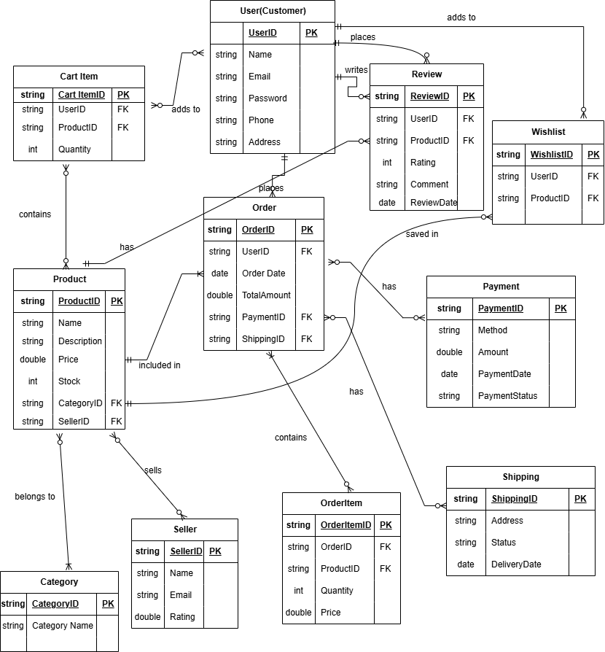

Conclusion
The ER diagram for the Amazon e-commerce system successfully models the logical structure and core relationships of a large-scale online marketplace. By defining entities such as User, Product, Order, Seller, and Payment with their respective attributes and constraints, the diagram provides a normalized and scalable blueprint for the database. The use of primary keys, and Crow’s Foot notation ensures data integrity and clearly illustrates the flow from product browsing to order fulfillment.
This design eliminates data redundancy and supports all critical functionalities, including user management, inventory tracking, cart operations, reviews, and transaction processing. Overall, the ER diagram serves as a strong foundation for implementing a robust, efficient, and maintainable database system that can handle the complex interactions of a real-word e-commerce platform like Amazon.

